AIAA Orange County (California) Section
TARC 2013 – November 25, 2012
Designing your TARC rocket
Purpose: The purpose of this document is to help someone with relatively little rocketry experience started in designing their rocket so it will not only meet the requirements but also be safe. It will describe what you need, and give you some of the options you have. It is not intended to be a “cookbook” for designing your rocket – you will need to do the research and apply that research in your design. And it will provide some links for that research to help answer remaining questions – keep exploring beyond the links provided. This document describes the elements of the design of a simple rocket that meets the specifications of the TARC rocket. During the design process you will have many choices. It is up to you to research what is best – your choices are listed here. You will use a CAD (computer aided design) program like Rocksim for designing your rocket. You will also use Rocksim to simulate launching your rocket to fine tune your rocket to the design specifications.
One fundamental rule of your design is that the Center of Gravity (CG) of your rocket must be ahead of the Center of Pressure of your rocket to make it stable.
- The Center of Gravity (CG) is the point where your completely assembled rocket, with engine, will balance on your finger, or if it was suspended by a string
- The Center of Pressure (CP) is the point where you would hold your rocket with two fingers – one on each side of the body tube - to keep it vertical if you took it outside on a windy day and held it up to the wind.
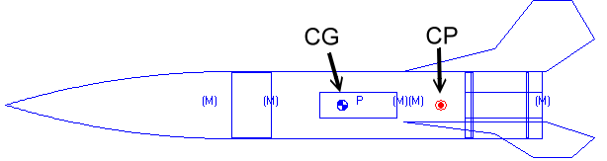
Image from: http://www.rocketreviews.com/what-is-cp.html
Rocksim will calculate the location of both of these values for you. For your design to be stable the CG must be ahead of the CP by at least 1 caliber (1 caliber = the diameter of the body tube of your rocket). This value is called the static margin of stability. Many model rocket web sites suggest this value be between 1 and 2; it can be larger, but rockets with a large value of static margin will weathercock more (turn into the wind instead of flying straight up).
Rocksim is available for purchase from Apogee Rocketry ($123.60) – TARC team members can purchase a 1 year license for a discount directly from Apogee ($6.00). And one member from each team can purchase a regular license for $60.00. The program is relatively easy to use once you get used to it.
Regular Rocksim can be found here:
http://www.apogeerockets.com/Rocket_Software/RockSim
The Rocksim discounts for TARC can be found here:
http://www.apogeerockets.com/Rocket_Software/RockSim_Educational_TARC
There are many tutorials on the Apogee Web site at:
http://www.apogeerockets.com/index.php?main_page=peak_of_flight_index#RockSim
Open Rocket is a free alternative to Rocksim:
http://openrocket.sourceforge.net/
For further reading (don’t stop with just these – keep researching!):
http://www.rockets4schools.org/images/Rocket.Stability.Flight.pdf
http://exploration.grc.nasa.gov/education/rocket/rktstab.html
http://www.info-central.org/?article=123
http://www.apogeerockets.com/Tech/Rocket_Stability
Parts of the rocket
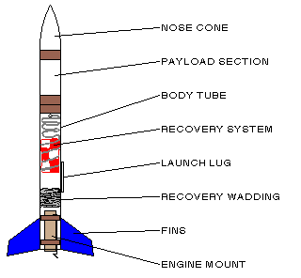

In the following sections we will look at the main parts of the rocket and see why they are necessary and provide some choices for design and materials

Image from: http://www.uni.edu/darrow/new/rockets/designing.html

Nose Cone
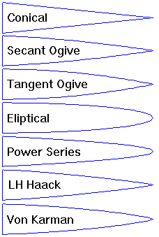
The shape, design, and finish of your rocket will affect drag. And drag is a force that will slow the rocket down. Since the nose cone contributes to the total drag of your rocket, you will need to give consideration to its shape. Common sense tells us that a flat front of the rocket will probably have the most drag, and a round or pointed front will probably have less drag. The shape of the nose cone becomes more important as the speed of the rocket increases – especially past Mach. Your TARC rocket will not exceed Mach. The Estes Model Rocket Technical Report TR-11 (link below) is commonly referred to when speaking of drag – be certain to check it out.
Common materials used for the nose cone are plastic (molded) and balsa wood. Plastic nose cones are made of varying thicknesses of plastic. Higher power rockets will use fiberglass or carbon fiber. Recalling the stability discussion above, the weight of your nose cone will affect the stability of the rocket. And it will affect the weight of your rocket – TARC imposes a limit on the total weight. You will want to select a nose cone shape and material in Rocksim – then locate a vendor where you can purchase it. Sometimes you cannot purchase exactly what you want and you will either need to fabricate your nose cone, or modify your selection. If this is your first TARC rocket, it is probably best to modify your selection. If you change the shape, material, or weight of the nose cone it will affect the flight of your rocket, so you will need to re-run your simulations (this will become more meaningful when you start to use Rocksim).
For further reading (don’t stop with just these – keep researching!):
http://sargrocket.org/Documents/Estes/TR-11.pdf
http://www.aerospaceweb.org/question/aerodynamics/q0151.shtml
http://www.grc.nasa.gov/WWW/k-12/rocket/rktaero.html
http://www.sigmarockets.com/blog/2012/04/the-aerodynamics-of-model-rockets-part-3-rocket-design-analysis/

Body Tube
As the name implies, the body tube is the main portion of the rocket – the airframe. There are several standard sizes for model rockets – it helps to stick with these sizes so that motors, bulkheads, centering rings, nose cones, and other commercially available parts will be available for construction. Body tubes for smaller rockets are most commonly made from thin or thick cardboard, cardboard covered with fiberglass, fiberglass, or carbon fiber (very light, very strong, very expensive). The tube for your motor mount will most probably be either 24mm or 29mm for “D”, “E”, or “F” motors. If you use the smaller “D” or even “E” motors, you might need a “cluster” of more than one.
Common thin walled (light weight) body tubes
Name | Inside Diameter | Outside Diameter | Weight (18” length) | Use
BT-5 | .518” (13.2mm) | 0.544” (13.8mm) | 0.205oz (5.8g) | Body Tube, 1/2A Engine Tube (14mm)
BT-20 | 0.71” (18mm) | 0.736” (18.7mm) | 0.286oz (8.1g) | Body Tube, A-B-C Engine Tube (18mm)
BT-50 | 0.95” (24.1mm) | 0.976” (24.8mm) | 0.384oz (10.9g) | Body Tube, D-E-F-G Engine Tube (24mm)
BT-55 | 1.283” (32.6mm) | 1.325” (33.7mm) | 0.705oz (20g) | Body Tube
BT-60 | 1.595” (40.5mm) | 1.6” (40.6mm) | 0.635oz (18g) | Body Tube
BT-70 | 2.18” (55.4mm) | 2.27” (56.3mm) | 1.291oz (36.6g) | Body Tube
BT-80 | 2.558” (65mm) | 2.6” (66mm) | 1.975oz (56g) | Body Tube
3” Thin Wall | 2.93” (74.4mm) | 3” (76.2mm) | 2.903oz (82.3g) | Body Tube
29mm | 1.14” (29mm) | 1.176” (29.9mm) | 0.459oz (13g) | F-G-H-I Engine tube (29mm)

Common thick walled (heavy weight) body tubes
Name | Inside Diameter | Outside Diameter | Weight | Use
2.56” | 2.56” (65mm) | 2.63” (66.8mm) | 5.573oz (158g) – 30” | Body Tube
3.00” | 3” (76.2mm) | 3.1” (78.7mm) | 7.972oz (226g) – 34” | Body Tube
29mm | 1.14” (29mm) | 1.21” (30.7mm) | 2.399oz (68g) – 34” | F-G-H-I Engine Tube (29mm)
38mm | 1.525” (38mm) | 1.635” (41.5mm) | 4.162oz (118g) – 24” | G-H-I-J Engine Tube (38mm)

Transitions
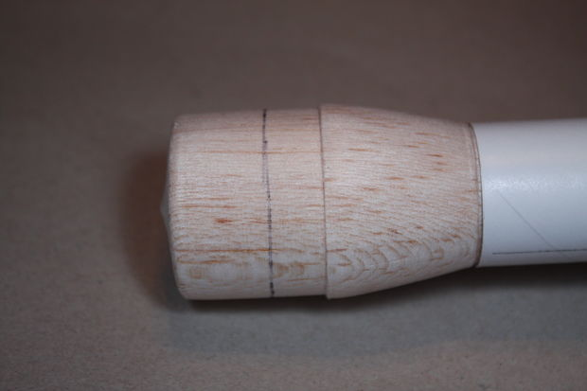
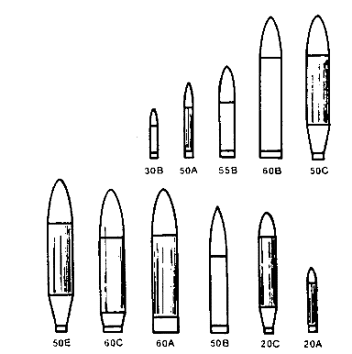

Image from: http://rocketry.wordpress.com/payloads/ and http://www.instructables.com
Not all rockets use the same size body tube from the nose cone to the motor end of the rocket. To avoid abrupt changes in your rocket which causes very turbulent air flow near the change, you may want to use a “transition”. A “transition” allows you to more gracefully change the diameter of the body tube of your rocket.

Tail Cones – Boat Tails
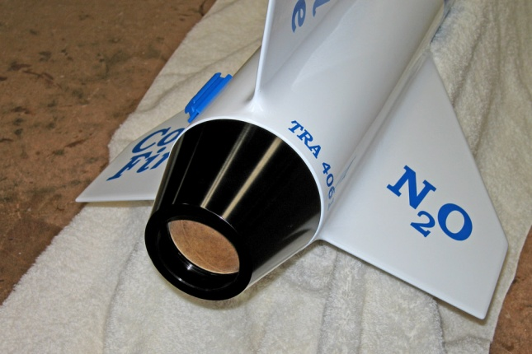
Another abrupt change in your rocket is the motor end. Very often the body tube just stops. This leaves some very turbulent air behind the rocket. This turbulent air contributes to drag – and worse yet that drag changes as the air swirls giving you inconsistent results. And that turbulent air contributes to pressure changes inside of your rocket motor as it burns, giving you inconsistent thrust. This is another variable that leads to inconsistent results from flight to flight. You can add a tail cone, or boat tail to smooth the flow – this is purely optional.
Image from: http://www.vernk.com/Construction/ColdfireMotorAdapter.htm
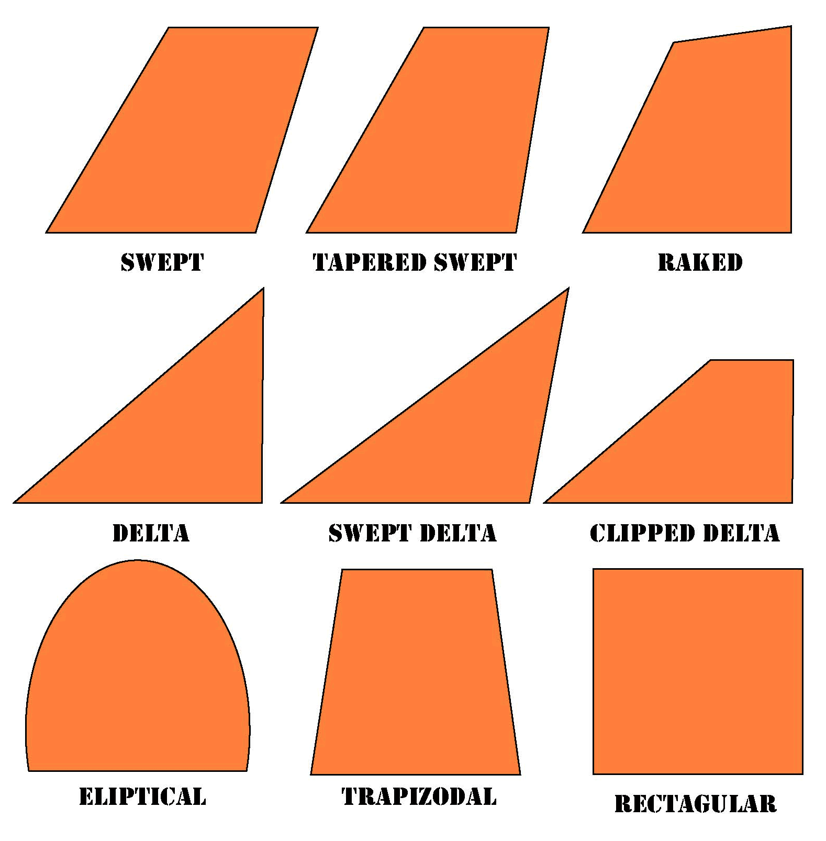
Fins

You can make your fins in a variety of shapes. If you search the Internet you will find a lot of studies on which fin shape is “best” – most of them come up with different conclusions.
You can also place an airfoil on your fins – so they look more like the cross section of the wing of an airplane. This helps that air flow, but be certain to make all of the fins exactly the same – including any taper that you add.

Image from: http://www.auburn.k12.ca.us/ev-cain

For further reading (don’t stop with just these – keep researching!):
http://www.nakka-rocketry.net/fins.html
http://www.2020vertical.com/nar_edu_cd_dev/lessons/apogee/Reports/Opt_fin_shape.pdf
http://www.apogeerockets.com/downloads/Newsletter50.pdf
http://rocketcontest.org/pdf/stem_student_tarc_handbook_sarradet.pdf (Note: NOT 2013 rules)
http://exploration.grc.nasa.gov/education/rocket/rktstab.html

Inside your rocket
The previous paragraphs have talked about your rocket from the outside. But there are a few more details you need to really get started:
Your rocket will need to come apart some place to allow ejection of the parachute. Rockets with no payload section usually separate between the body tube and the nose cone. Rockets with a payload section usually have two body tubes – one with the motor and a second attached to the nose cone. The payload (for TARC this will be your egg and altimeter) goes in that second body tube attached to the nose cone. The altimeter should be mounted securely, yet removable. And you need a port for your altimeter – a small, clean hole in the payload to equalize pressure so the barometric pressure sensor on the altimeter can work properly. The size of the hole is important and depends upon the volume of your payload bay – check the instructions for the altimeter.
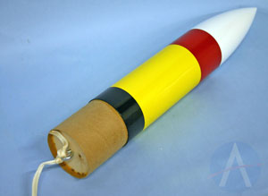
The nose cone (removable) goes on one end of the piece of body tube, a coupler (a special piece of body tube designed to fit inside of the outside body tube) is glued to the other – ½ inside the body tube and ½ sticking outside of the body tube. Inside the end of the coupler that sticks out you will need a bulkhead and a way to attach a shock cord (like an eyebolt). This bulkhead shields your payload from the ejection charge of the motor that pushes out the parachute, so it must be air tight.

Image from: http://www.apogeerockets.com/Rocket_Kits/Skill_Level_3_Kits/Patriot_Missile
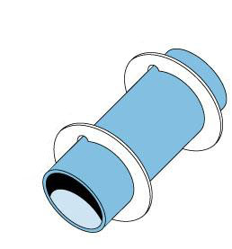
The other half of your rocket will have fins and the motor. For TARC, the inner diameter of your body tube will probably not be the same as the outer diameter of your motor. For this you need a motor tube, similar to the body tube, but of a specific diameter (24mm and 29mm are most common for the “E” and “F” motors). And you will need centering rings to hold this motor mount inside of your larger body tube. The outer diameter of the centering rings will match the inner diameter of your body tube. And there will be a hold in each centering ring that matches the outer diameter of your motor tube. These parts are readily available as long as you stick with the standard sizes. Two centering rings are usually sufficient.
Image from: http://web4.hobbylinc.com/gr/est/est303159.jpg
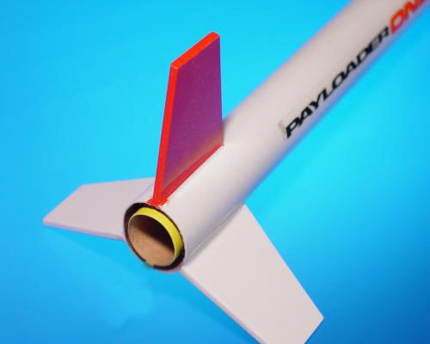
This whole motor assembly is glued to one end of the second body tube. You put the two pieces together by sliding the piece of coupler sticking out of the top body tube into the body tube with the fins. And you will need a method to hold the motor in place so, when the ejection charge goes off, the parachute is pushed out and not the motor. You can use a mechanical restraint, or wrap masking tape around the motor for a friction fit. And you can attach your fins on the surface, or stronger is to use “through the wall” fins.
Image from: http://www.questaerospace.com/ItemDesc.asp?IC=5485
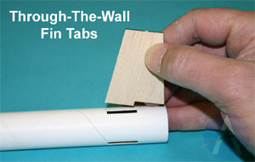
Fins can be made of a variety of materials. Cardboard, balsa wood, plywood, fiberglass, and carbon fiber – some with molded airfoils are popular. Balsa wood is popular for very small rockets and could be used for a TARC rocket – especially if covered in paper to increase strenght. One-eight inch plywod is a good compromise between weight and strength. Remember that we want to keep the CG forward, so heavy fins work against that goal.
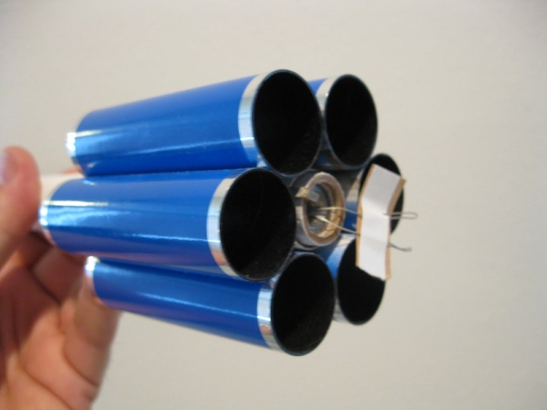
We tend to think of rockets as having 3 or 4 tiny “wings” near the motor end of the rocket. But there are other form factors for “fins”. Relatively popular (but not for TARC) are tube fins. As with most options, they come with good and bad. One good feature is that a rocket with tube fins tends to weather cock less. In general (except for very small body tubes), six tube fins of the same diameter as the body will fit nicely. And the length of each tube is critical for proper performance (start with 0.9 x body tube diameter).
For further reading:
http://rocketdungeon.blogspot.com/2008/01/tube-fin-performance.html

Inside of the empty cavity of the body tube with fins is where your recovery device goes – this would be your parachute(s). And you will need to use shock cord to attach the parachute to the body tube. If you choose to use one 15” parachute to recover the entire rocket, you will need to use a long shock cord (5x the length of the rocket) to tie the two body tubes together. You will really need to watch the weight or you will not meet the flight time criterion, since the parachute is so small the rocket will descend rapidly. Or you can have the two pieces separate and each would come down on its own parachute. The payload section MUST use a 15” parachute; the other section can use any size parachute as long as it descends safely. The shock cord should not burn or melt – kevlar works well but does not stretch. If you are tying the two pieces of rocket together, then you should use a piece of nylon or elastic with the Kevlar. And you need to protect your parachute(s) from the ejection charge. A swivel will help to avoid getting the parachute shroud lines tangled. You should have a small (1/8” or less) hole in this section to vent the pressure that builds up during ascent
Launch Lug
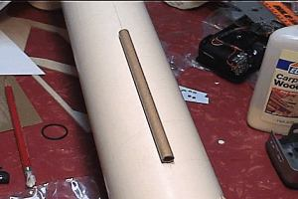
You will also need a launch lug on your rocket – ¼” is standard for TARC. If you are using one lug it should be placed at the center of gravity – or you can use two. The launch pads have a ¼” rod to guide the rocket until it is going fast enough to be stable.

Image from: http://www.joecool.org/forte_construction.htm

