AIAA Orange County Section

Student Launch Initiative 2010-2011

Post Launch Assessment Review

Project M1
Quantification of the effects of acceleration on hard disk drive latency
Submitted by:
AIAA Orange County Section
NASA Student Launch Initiative Team
Orange County, CA
Submitted to:
Marshall Space Flight Center
Huntsville, Alabama
May 9, 2011
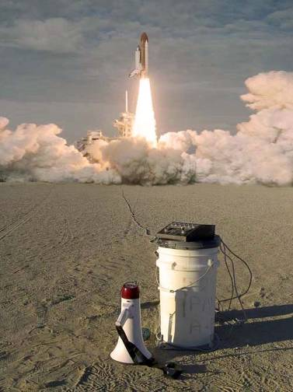
Image From: XPRS.ORG
Project Manager
Sjoen Koepke
Website: http://AIAAOCRocketry.org
Post-Launch Assessment Review (PLAR)
- Team name
The team name of the AIAA Orange County Student Launch Initiative is “M1.”
- Motor used
The motor that was used was a Ceseroni K635 Red Lighting.
- Brief payload description
The payload of our rocket will contain a small Linux computer, a laptop hard drive and supporting circuitry. The payload is powered by three 8.4 volt Lithium Ion battery packs. The linear tech DC 187/converter converts raw battery voltage to power the experiment. We will be measuring the acceleration experienced by the rocket using a G-Wiz Partners HCX flight computer. During the launch the hard drive will be subjected to forces and vibration. The hard drive will be operational during the flight. This will ultimately test the survivability of the hard drive as well as performance degradation during the flight. We will be testing hard drive latency in milliseconds. This will be recorded by a solid state thumb drive.
- Rocket height
The height of our team’s rocket is 87.5 inches.
- Rocket diameter
The diameter of our teams rocket is 4 inches.
- Rocket mass
The mass of our rocket is 17.9 pounds.
- Altitude reached (feet)
The altitude that our teams rocket reached was 5,582
- Vehicle summary
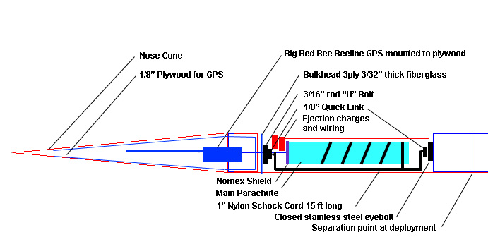
Our teams vehicle was a modified black brant. The nose cone is 20 inches long, and the top section of body tube is 24 inches, with 16 inches usable.
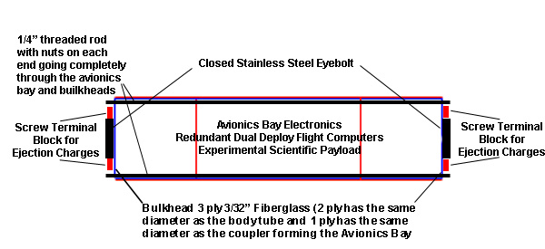
The avionics bay is 16 inches long; 4 inches on both sides are couplers.
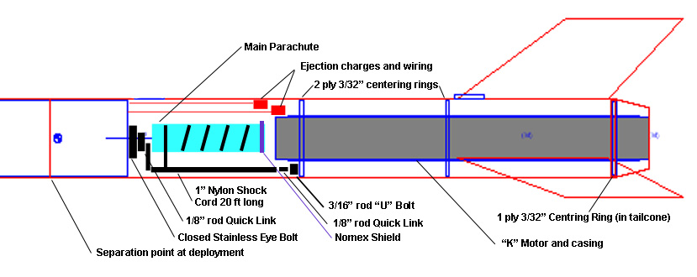
The bottom section is 31 inches, with 8 inches useable.
- Data analysis & results of vehicle
We used a G-Wiz partners HCX Flight computer as the main computer in the dual redundant recovery system. The HCX measures altitude using a barometric sensor AND an accelerometer, and records this data on a removable memory card. After the flight we downloaded the data from this card and let the G-Wiz Partners FlightView program analyze and present the data. The Flight Summary tab provides the data that until now we had only been able to simulate using Rocksim.
  - Flight Summary
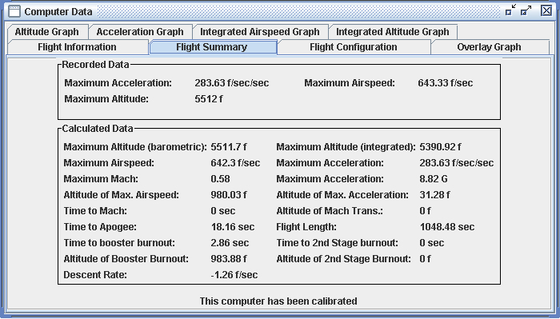
We can then compare this actual data against the data from the Rocksim flight simulation (data from the flight summary sheet and the details during the simulation):
Parameter | RockSim | Flight Data from HCX | Rocksim as a percentage of HCX
Altitude | 5266 ft | 5512 ft | 95%
Maximum Speed (ft/s) | 686 ft/s | 643 ft/s | 107%
Maximum Air Speed (mach) | .61 | .58 | 107%
Altitude at maximum airspeed | 1031 ft | 980 ft | 105%
Maximum Acceleration (ft/s) | 435 ft/s | 284 ft/s | 153%
Maximum Acceleration (“G’s) | 13.59 G’s | 8.82 G’s | 153%
Altitude of maximum acceleration | 22.73 | 31.28 ft | 73%
Time to booster burn-out | 3.13 seconds | 2.86 seconds | 109%
Altitude of booster burn-out | 1234 ft | 983.9 ft | 125%
Time to apogee | 17.66 ft | 18.2 seconds | 97%
The values in general are quite close (within 10% of each other) which seems reasonable. The large discrepancy in altitude at booster burn out is a result of the time to booster burn-out variation which is within the manufacturing tolerance of the engines. The large difference in acceleration, though, remains unexplained.
  - Flight Altitude
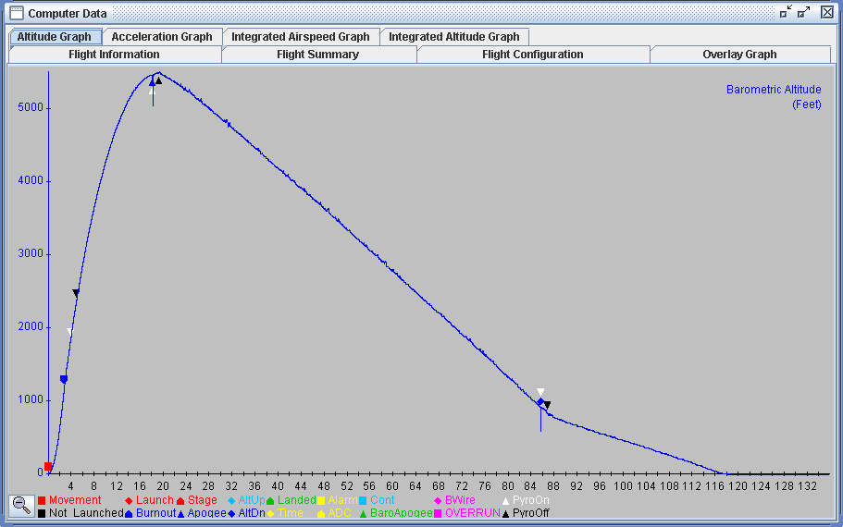
This altitude graph from the HCX shows the altitude over the time of the flight. The table below summarizes the altitude at apogee

Flight Time | Flight Altitude | Descent Time | Descent Distance | Descent Rate
Drogue
17 s | 5512 ft | 68.5 seconds | 4612 ft | 67.33 ft/s
85.5 s | 900 ft
Main
85.5 s | 900 ft | 32.5 seconds | 900 ft | 27.6 ft/s
118s | 0 ft

The target for the drogue was 50 to 100 ft/s; the HCX flight data shows the descent rate meeting this target. However, descent rate for the main was targeted at 17 to 22 ft/s and this rocket was outside of that range by approximately 25%
  - Time vs Altitude, Acceleration, and Speed
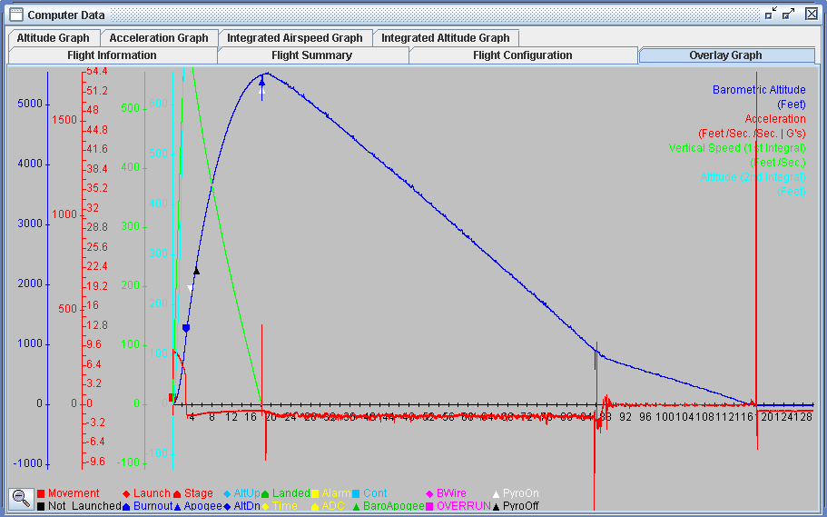

This graph, again from the HCX flight computer plots our flight time versus barometric altitude as well as acceleration, altitude, and speed as calculated from the accelerometer.

- Payload summary
The payload consists of:
- DC-DC power converter
- Hard drive
- Linux mini computer
- Flash drive—inserted into Linux mini computer
Our experiment was to find out how the hard drive latency is affected by external forces. The flash drive inserted into the Linux computer contains a shell script—the Linux computer will execute the script on the hard drive. The script is executed again and again, and the time elapsed during each execution is recorded on the flash drive. The DC-DC power converter is installed to ensure a stable voltage input to the payload components, so there will be no errant variation in the data due to voltage difference.
The final shell script is as follows:

#!/bin/sh
PATH=/bin
while true
do
date >>/var/ftp/LEXAR/log.txt
time dd if=/dev/zero of=/dev/sdb2 bs=65536 count=32 skip=64>>/var/ftp/LEXAR/log.txt 2>&1
time sync >>/var/ftp/LEXAR/log.txt 2>&1
time dd if=/dev/zero of=/dev/sdb2 bs=65536 count=32 skip=128>>/var/ftp/LEXAR/log.txt 2>&1
time sync >>/var/ftp/LEXAR/log.txt 2>&1
tail -n 10 /var/ftp/LEXAR/log.txt
done

- Data analysis & results of payload
The first launch of the full scale rocket was with the old Toshiba hard drive, and data collection stopped shortly after launch. The hard drive went into shock protection mode and stopped doing work for the duration of the launch. Therefore, the Linux computer could not communicate with the hard drive until the hard drive reverted back to normal—we got lines and lines of error. After the launch, we tested to see if the hard drive was intact, and it was. We decided to use a different hard drive to see if it could provide more meaningful data. Most importantly, we were wary that the old hard drive might have been somewhat corrupted.
On the next launch, we used a new Seagate hard drive. As with the previous launch, the hard drive also went into protection mode, and the data collected was meaningless. Again, the hard drive was still operational after launch. We concluded that the hard drive could not withstand the forces exerted on it while running, and that the hard drive would self-destruct if shock protection was removed. We therefore used a raw format so that the hard drive skips over corrupted lines of code, and still runs properly.
The final launch at Huntsville was not alike the last two launches, but we found an outstanding measurement in our data:
Fri Feb 11 23:14:03 UTC 2011
32+0 records in
32+0 records out
real 0m 0.88s
user 0m 0.00s
sys 0m 0.22s
real 0m 0.05s
user 0m 0.01s
sys 0m 0.02s
32+0 records in
32+0 records out
real 1m 37.96s
user 0m 0.00s
sys 0m 0.22s
real 0m 0.16s
user 0m 0.00s
sys 0m 0.03s
Fri Feb 11 23:15:43 UTC 2011
dd: can't open '/dev/sdb2': No such device or address
Command exited with non-zero status 1
real 0m 0.14s
user 0m 0.01s
sys 0m 0.11s
real 0m 0.07s
user 0m 0.00s
sys 0m 0.02s
At rest, the hard drive would take anywhere from approximately 0.6 seconds to 0.9 seconds to execute the script once. The hard drive took approximately 1 minute and 40 seconds to execute the script at launch, shortly before it shutdown. The increase in force caused a tremendous increase in hard drive latency.
- Scientific value
The science payload objectives are:
- Experiment must be practical
- Control variable can be set
- Collect data
- Data must be retrievable from the Simple Net computer
- A conclusion can be reached from the data accumulated

The mission success criteria are as follows:
- Experiment is practical (not too expensive, not too large, etc.)
- Control variables can be set
- Collects data
- Data must be retrievable from the simple net computer
- A conclusion can be reached from the data accumulated (hypothesis proved or disproved)

Before the experiment, we tested our script on the hard drive to measure its latency under ideal conditions. Since our experiment involved the hard drive doing work when under stress, we devised the script so that it bypassed cache memory. Additionally, in an attempt to get as many measurements of hard drive latency as possible during the short burn time of the launch, we wrote the script to measure latency every 0.1s.
From the three launches of the full-scale rocket, we learned that the hard drive is unable to handle the forces caused by a launch, especially when it is running. The hard drive went into protection mode for the duration of the launch—we were afraid to disable the protection for fear of destroying the hard drive. If we turned off protection, the assembly head may scratch the disk or detach, rendering the hard drive useless.

- Visual data observed
The rockets flight was very straight in calm wind. The drogue was fired at apogee, back up charge did fire, and brought the rocket down at a good speed. The main brought down our rocket faster than what we planned. The rocket returned with no damage.

- Lessons learned
There are many things that our team has learned not only things have to do with the vehicle. The team learned that to be able to do this project that there needs to be constant communication because if not multiple people will do the same section, or have two different sets of information. Next is a high level of team work, if you don’t work as a team then your project won’t be completed because a single person can’t work alone when there’s fifteen others trying to do the same, information would lost. Everyone is important because they bring something different to solve problems, if not everyone had helped then problems would have stayed and continued to cause more problems. If you’re not patient then team members will become frustrated, but if you’re too patient things will not get done. As a project manager you learn how to manage people and how to overcome problems without loosing time.

These are tables of our vehicle lessons learned:
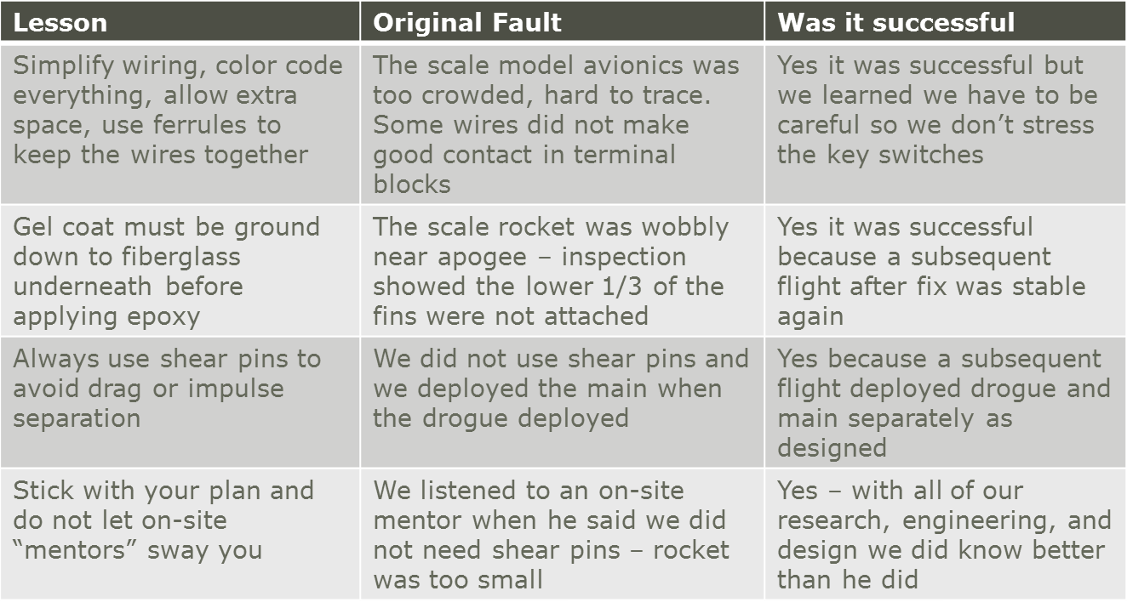
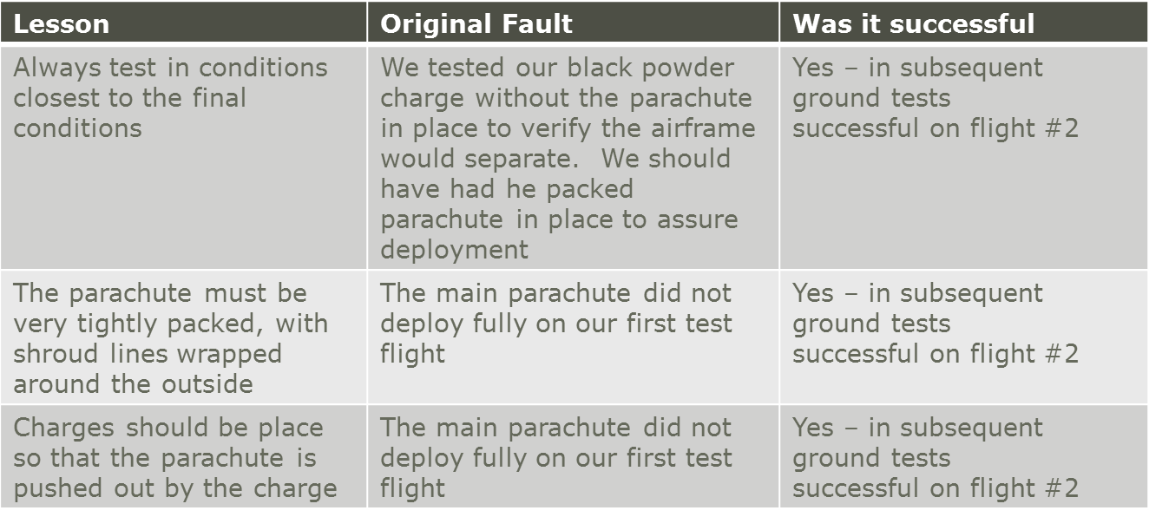

The following is lessons learned from the payload.
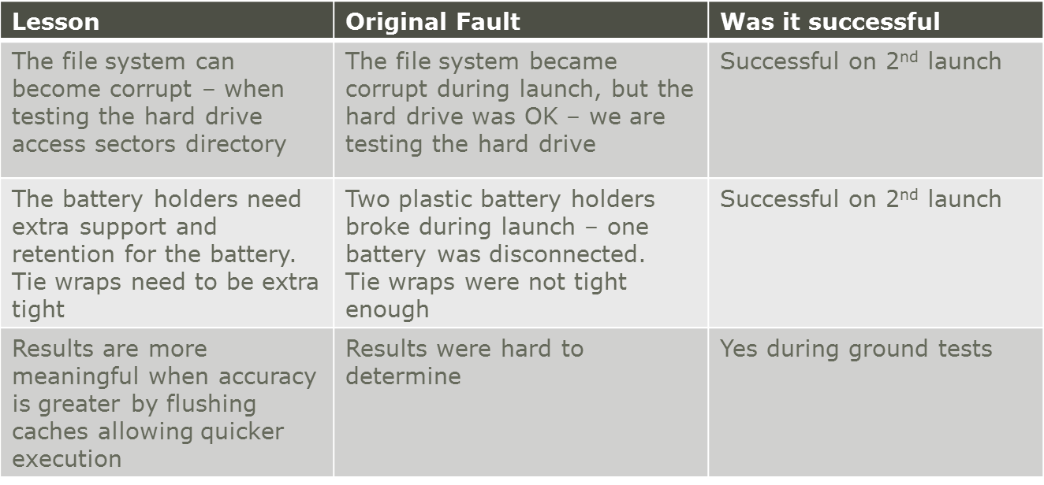

- Summary of overall experience
This experience helped all the team members learn and grow. It also offered a real world experience of what to expect, not only in a NASA project but in any project at all. It showed that there are many types jobs involved in a single project, and many different types of people are required to complete a project. This project help the team learn that communication and a deep understanding of the project is required to successfully complete the project. The project helped fuel more inspiration in pursuing an aerospace and/or engineering as a career.
- Educational engagement summary
Event | Date | Number of Kids | Number of Adults
Girl Scouts Build | 10/16/2010 | 40
Girl Scouts Launch | 11/6/2010 | 20
Cloverdale 4H | 1/4/2011 | 13 | 7
AIAA Presentation | 1/11/2011 |  | 30
Youth Expo | 4/8/2011 – 4/10/2011 | 150 | 250
Presentation to Team Members High School | 5/12/2011 | n/a | n/a
ASAT Conference | 5/21/2011 | n/a | n/a
Article in Sunny Hills Newspaper
Article in Foot Hill Sentry

Our team did many educational engagement events. October 10th and November 6 our team helped the girl scouts build a rocket and then helped them learn how to prep the rocket for launch. There was a different set of kids at the launch. On January 4th our team gave a presentation to Cloverdale 4H about rocketry, TARC and SLI. On January 11th a presentation was given to AIAA about what TARC and SLI is and more information about what the team is doing. April 8th to April 10th was Youth Expo in which our team informed the public about rocketry, TARC, and SLI.
- Budget summary
This is a table showing our budget costs vs the actual costs.
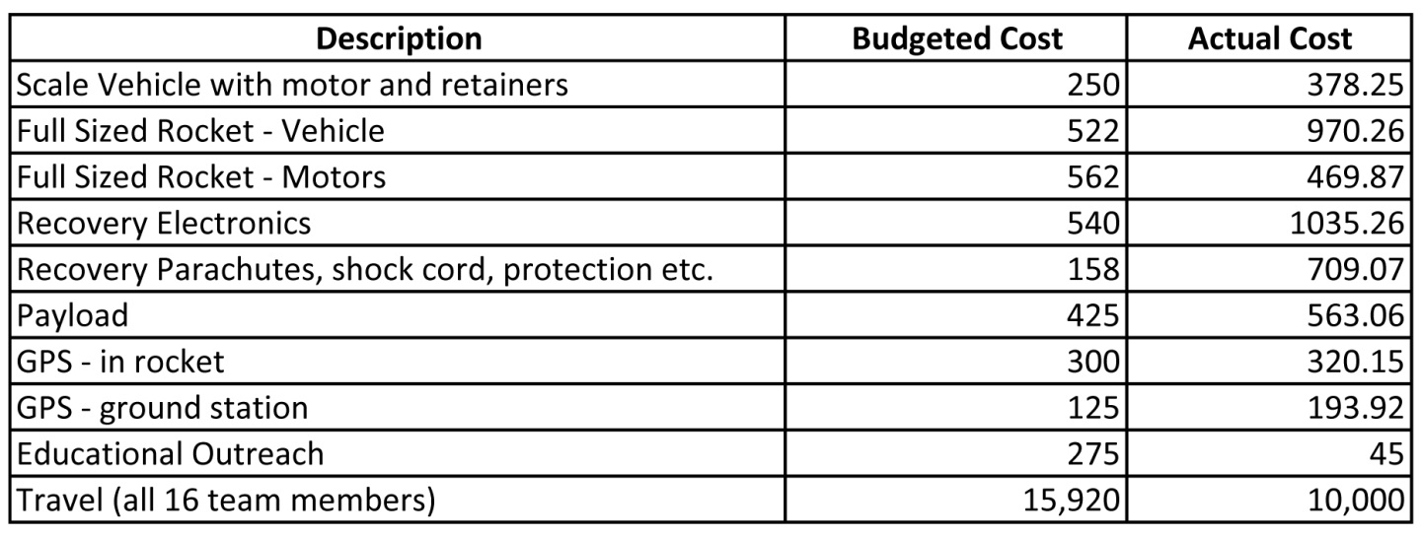
We went over for our vehicle because we bought many more bulkheads to increase the thickness of them. We also bought a bottom section to use as a top. We bought back up recovery electronics which explains the doubled actual cost. We also bought extra parachutes and shock cords in different lengths. For the educational engagements we only had to pay for insurance at youth expo. The travel to Huntsville cost about six grand less because only ten team members attended the launch.

